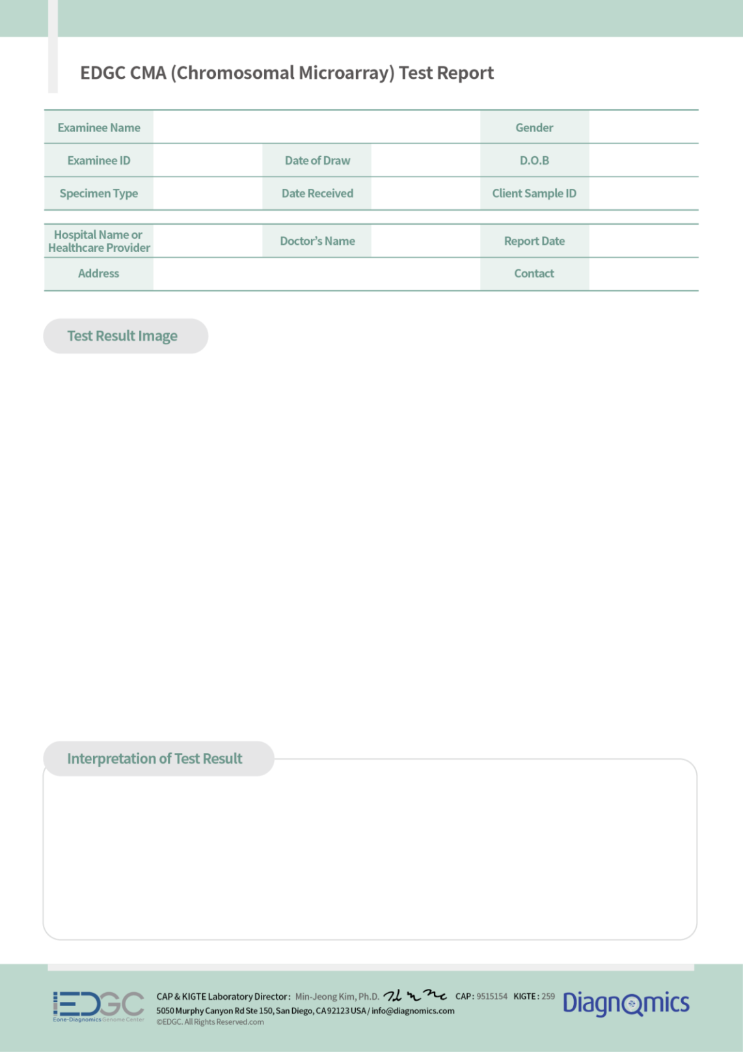
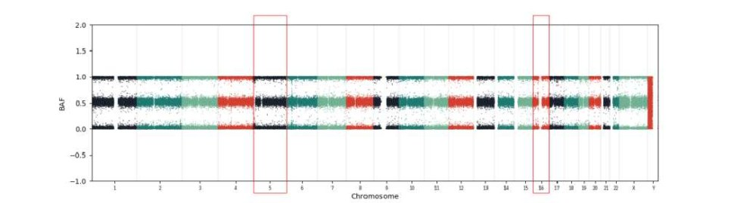
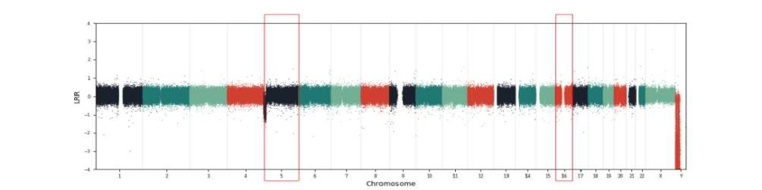
PAEZ NATASHA Female

D2695901

Blood

GENDA
22-Jul-2026

27-Jul-2026

Pilar Igarreta
2019-06-18

D2695901

03-Aug-2026

Pathogenic variant found
*duplication(X3) of 0.59 MB (chr16:29,595,483-30,187,676) in the 16p11.2 region, Pathogenic 16p11.2 recurrent region (BP4-BP5) is likely to cause pathogenic phenotype.
*deletion(X1) of 12.75 MB (chr5:14,782-12,771,257) in the 5p15.33-15.2 region, Pathogenic
The 5p15.33-15.2 deletion contains the TERT morbid gene, which is known to be associated with Cri du chat syndrome.
References:
https://search.clinicalgenome.org/kb/gene-dosage/region/ISCA-37400 https://search.clinicalgenome.org/kb/gene-dosage/region/ISCA-37390 https://www.sciencedirect.com/science/article/abs/pii/S1090379820301434

CytoBand

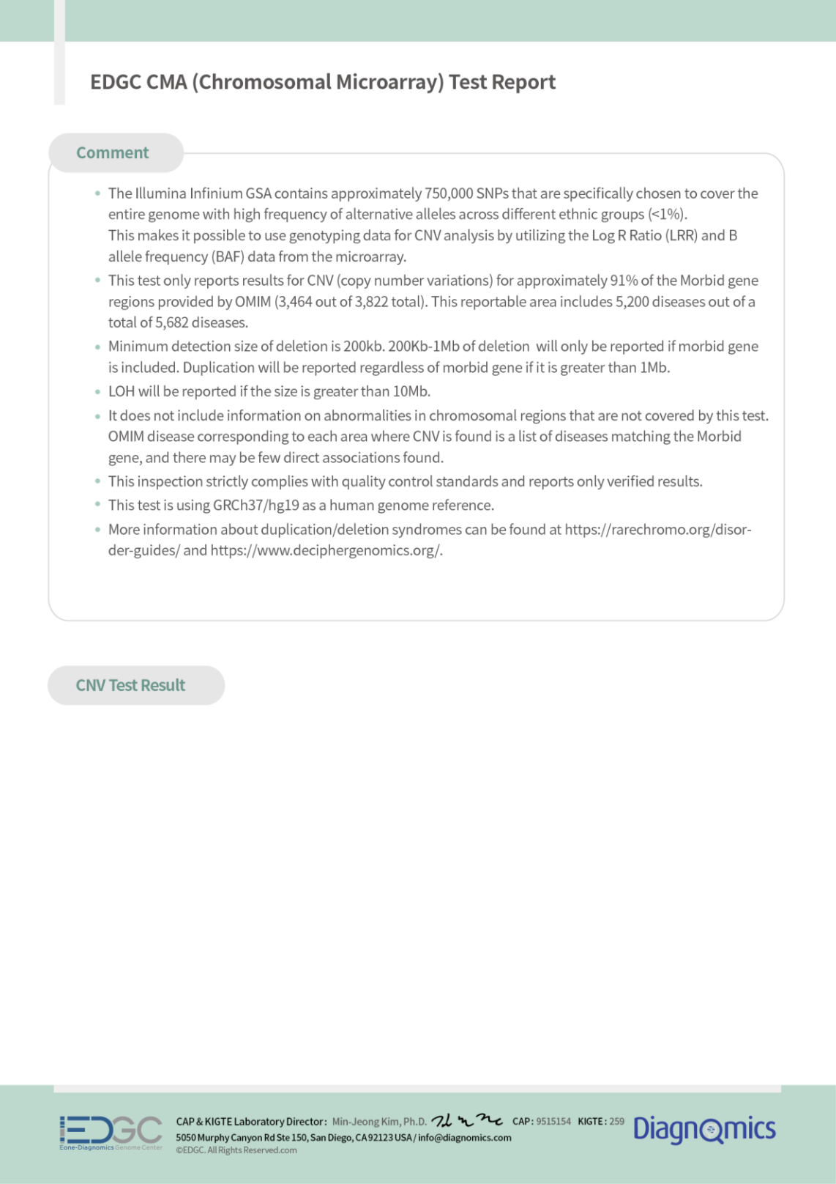
5p15.33-15.2
Position

chr5:14782-12771257
Type

DEL(X1)
Disease

Neuropathy, hereditary sensory, with spastic paraplegia
Mosaic variegated aneuploidy syndrome 3
Oocyte/zygote/embryo maturation arrest 9
Intellectual developmental disorder, autosomal recessive 5
Mitochondrial complex I deficiency, nuclear type 9
Diarrhea 8, secretory sodium, congenital

Hartnup disorder

Neurodegeneration with ataxia and late-onset optic atrophy
Mitochondrial complex II deficiency, nuclear type 1
Inheritance

Autosomal recessive
Autosomal recessive
Autosomal recessive
Autosomal recessive
Autosomal recessive
Autosomal recessive
Autosomal recessive
Autosomal dominant
Autosomal recessive
Gene

CCT5

TRIP13

TRIP13

NSUN2

NDUFS6

SLC9A3

SLC6A19

SDHA

SDHA
Reference

610150

604507

604507

610916

603848

182307

608893

600857

600857

CytoBand

5p15.33-15.2
Position

chr5:14782-12771257
Type

DEL(X1)
Disease

Cardiomyopathy, dilated, 1GG

Pheochromocytoma/paraganglioma syndrome 5

Epilepsy, familial adult myoclonic, 3

Leukemia, acute myeloid

Dyskeratosis congenita, autosomal dominant 2

Dyskeratosis congenita, autosomal recessive 4

Pulmonary fibrosis and/or bone marrow failure syndrome, telomere-related, 1
Inheritance

Autosomal recessive
Autosomal dominant
Autosomal dominant
Somatic mutation, Autosomal dominant
Autosomal recessive, Autosomal
Autosomal recessive, Autosomal

Autosomal dominant
Gene Reference

SDHA 600857

SDHA 600857

MARCH6 613297

TERT 187270

TERT 187270

TERT 187270

TERT 187270

CytoBand

5p15.33-15.2

16p11.2
Position

chr5:14782-12771257

chr16:29595483-30187676
Type

DEL(X1)

AMP(X3)
Disease

Melanoma, cutaneous malignant, 9

Nicotine dependence, protection against

Parkinsonism-dystonia, infantile, 1

Neural tube defects, folate-sensitive, susceptibility to
Homocystinuria-megaloblastic anemia, cbl E type

Episodic kinesigenic dyskinesia 1

Convulsions, familial infantile, with paroxysmal choreoathetosis

Seizures, benign familial infantile, 2

Cone-rod dystrophy 22
Inheritance

Autosomal dominant

-

Autosomal recessive
Autosomal recessive
Autosomal recessive
Autosomal dominant
Autosomal dominant
Autosomal dominant
Autosomal recessive
Gene Reference

TERT 187270

SLC6A3 126455

SLC6A3 126455

MTRR 602568

MTRR 602568

PRRT2 614386

PRRT2 614386

PRRT2 614386

FAM57B 615175

CytoBand

16p11.2
Position

chr16:29595483-30187676
Type

AMP(X3)
Disease

Glycogen storage disease XII

Spondylocostal dysostosis 5

Spondyloepimetaphyseal dysplasia with joint laxity, type 2
Inheritance

Autosomal recessive
Autosomal recessive, Autosomal
Autosomal dominant
Gene Reference

ALDOA 103850

TBX6 602427

KIF22 603213
